Project 3: Design & Specification

## **Executive Summary**

Anybody can order from bricklink.com. The design of the new bricklink.com website shopping cart will bring together all the features of the ordering process into one cohesive unit. From start to finish, the path a customer takes from finding a seller to making a payment will be clear.

## **Design: Breadth-First**

|  |  |  |  |  |
| --- | --- | --- | --- | --- |
|  | **Horizontal, One-Page**  This design has all the checkout options on one page. There are three divided sections for order info, shipping info, and Payment info. Payment info opens in a new screen where you enter either PayPal information or a credit card. You click on the Pay Now button and you’re done! | | | |
| **Criteria** | **Weight** | **Score** | **Comment** |
| **Speed** | **30%** | **2** | Everything on one page is very convenient and quick. Users can see everything at once. |
| **Complete** | **30%** | **-2** | There’s some very important information missing such as where the items are shipping from and how the shipping is being accounted for. |
| **Authentic** | **30%** | **0** | With the PayPal Logo and correct credit card security, the users will be certain they placed an order. An email confirmation will be assured when a notice is placed that an address is required. |
| **Regular** | **10%** | **1** | Most checkouts have multiple pages, so this might be unfamiliar to a customer. However, the questions and information required will be familiar. |
| **Score:** | **0.1** | | |

|  |  |  |  |  |
| --- | --- | --- | --- | --- |
|  | **Vertical, One-Page**  This design also has all the checkout options on one page. There are three divided sections for order info, shipping info, and Payment info. This time the shipping options are included separately for each seller. This way the shipping is separate for each part of the order. Its layout is vertical to allow more space. | | | |
| **Criteria** | **Weight** | **Score** | **Comment** |
| **Speed** | **30%** | **2** | Again, all the options are on one page for this design. This greatly reduces the amount of time required to make an order. |
| **Complete** | **30%** | **-1** | There is more information this time, but there is still missing some important options, such as the seller’s location. It would also be helpful to have the shipping address be confirmed before shipping costs are calculated. |
| **Authentic** | **30%** | **0** | With the PayPal Logo and correct credit card security, the users will be certain they placed an order. An email confirmation will be assured when a notice is placed that an address is required. |
| **Regular** | **10%** | **1** | Again, most checkouts have multiple pages, so this might be unfamiliar to a customer. However, the questions and information required will be familiar. |
| **Score:** | **0.4** | | |

|  |  |  |  |  |
| --- | --- | --- | --- | --- |
|  | **Multiple Pages**  This design has all the checkout options on one page. There are three divided sections for order info, shipping info, and Payment info. Payment info opens in a new screen where you enter either PayPal information or a credit card. You click on the Pay Now button are you’re done! | | | |
| **Criteria** | **Weight** | **Score** | **Comment** |
| **Speed** | **30%** | **-1** | This design may be quicker than the current website, but the multiple pages and options will take much too long to navigate. |
| **Complete** | **30%** | **1** | It looks like most of the options are here. There could be more choices like blocking certain sellers choosing a seller’s rating etc. |
| **Authentic** | **30%** | **0** | With the PayPal Logo and correct credit card security, the users will be certain they placed an order. An email confirmation will be assured when a notice is placed that an address is required. |
| **Regular** | **10%** | **0** | The same options as other websites. Nothing special here. It isn’t better or worse than most. |
| **Score:** | **0** | | |

|  |  |  |  |  |
| --- | --- | --- | --- | --- |
|  | **Two Pages with Shipping options**  This design has all the checkout options on one page. There are three divided sections for order info, shipping info, and Payment info. Payment info opens in a new screen where you enter either PayPal information or a credit card. You click on the Pay Now button are you’re done! | | | |
| **Criteria** | **Weight** | **Score** | **Comment** |
| **Speed** | **30%** | **1.5** | With only two pages, we got a great head start. It may not be as succinct as a one-page layout, but it’s much better than the original. |
| **Complete** | **30%** | **1.5** | The options are there so that’s great! |
| **Authentic** | **30%** | **0** | Still the same here. What could make it better and more trustworthy? Maybe a notice about receiving an email confirmation or a thank you page after the order has been completed. |
| **Regular** | **10%** | **-1** | There might be some confusion here with the shipping options. I’ve seen some websites that ask for an address to confirm costs, but I wonder if a log-in requirement would eliminate the need to go through this or if that would scare some people away. |
| **Score:** | **0.8** | | |

## **Design: Depth-First**

|  |  |  |  |  |
| --- | --- | --- | --- | --- |
|  | **Two Pages with Shipping options | Refined 1** | | | |
| **Criteria** | **Weight** | **Score** |  |
| **Speed** | **30%** | **1.5** | I think the two pages will be pretty standard at this point. Putting everyone on one page sounds nice, but isn’t practical when trying to include all the required information. |
| **Complete** | **30%** | **1.5** | To exclude some sellers from the results, the user could add that to their account settings. That eliminates the need to create that option for every order. Only the options specific to that order will be included. |
| **Authentic** | **30%** | **0** | Just normal. I need to add notices or a confirmation page. |
| **Regular** | **10%** | **1** | Pretty normal. I like the shipping costs included with each’s seller’s information. That groups things in a way that is clear and normal for a customer. |
| **Score:** | **1** | | |

|  |  |  |  |  |
| --- | --- | --- | --- | --- |
|  | **Two Pages with Shipping options | Refined 2**  Getting closer. This layout has 2 pages. The first is a review page with a simple list of items wanted, a section to confirm the customer’s information and a section to choose options such as the condition of the item and where the seller is located. The second page combines the customer’s needs with what’s available. | | | |
| **Criteria** | **Weight** | **Score** |  |
| **Speed** | **30%** | **1.5** | This is going well. I like the two pages. I feel like it’s a fairly quick process, especially if the shipping address and customer information is already filled in because they are logged in. I think some wayfinding at the top of the pages would clarify how many steps are needed to finish an order. |
| **Complete** | **30%** | **-1** | There’s a little bit of confusion here still. The “item condition” only lets the customer choose for all the items combined. It would be better to choose for each individual item. That should be included when the item is first chosen and then displayed on the “Review Your Order” list on the first page with the option to change. I forgot to add in the shipping for each seller. |
| **Authentic** | **30%** | **0** | I forgot to add a notice about email confirmation. I wonder about the clarity of the red buttons. |
| **Regular** | **10%** | **1** | This is slightly different from a regular checkout because it contains options that are different than some. But it still scores well because the usual requirements are there. |
| **Score:** | **0.25** | | |

|  |  |  |  |  |
| --- | --- | --- | --- | --- |
| **Build Your Order**    **Verify Order**    **Confirmation** | **Two Pages + Confirmation | Final**  This version compiles all the needed elements of the checkout process. There is a third screen but this is only a confirmation of an order that has been placed. | | | |
| **Criteria** | **Weight** | **Score** |  |
| **Speed** | **30%** | **1.5** | Only two pages to fill out. The address should autofill from the required log-in when placing an order. But you can still edit that address within the field. |
| **Complete** | **30%** | **2** | Checklist:  Item list with the condition for each line item  Shipping address confirmation  Options for Seller location and rating  Itemized list with each seller/shipping separate  Simplified payment options |
| **Authentic** | **30%** | **1.5** | A confirmation page with order details  Includes required email field |
| **Regular** | **10%** | **1** | Most items are what is expected when placing an online order. Wayfinding at the top helps with understanding the process. |
| **Score:** | **1.6** | | |

## **Final Design**

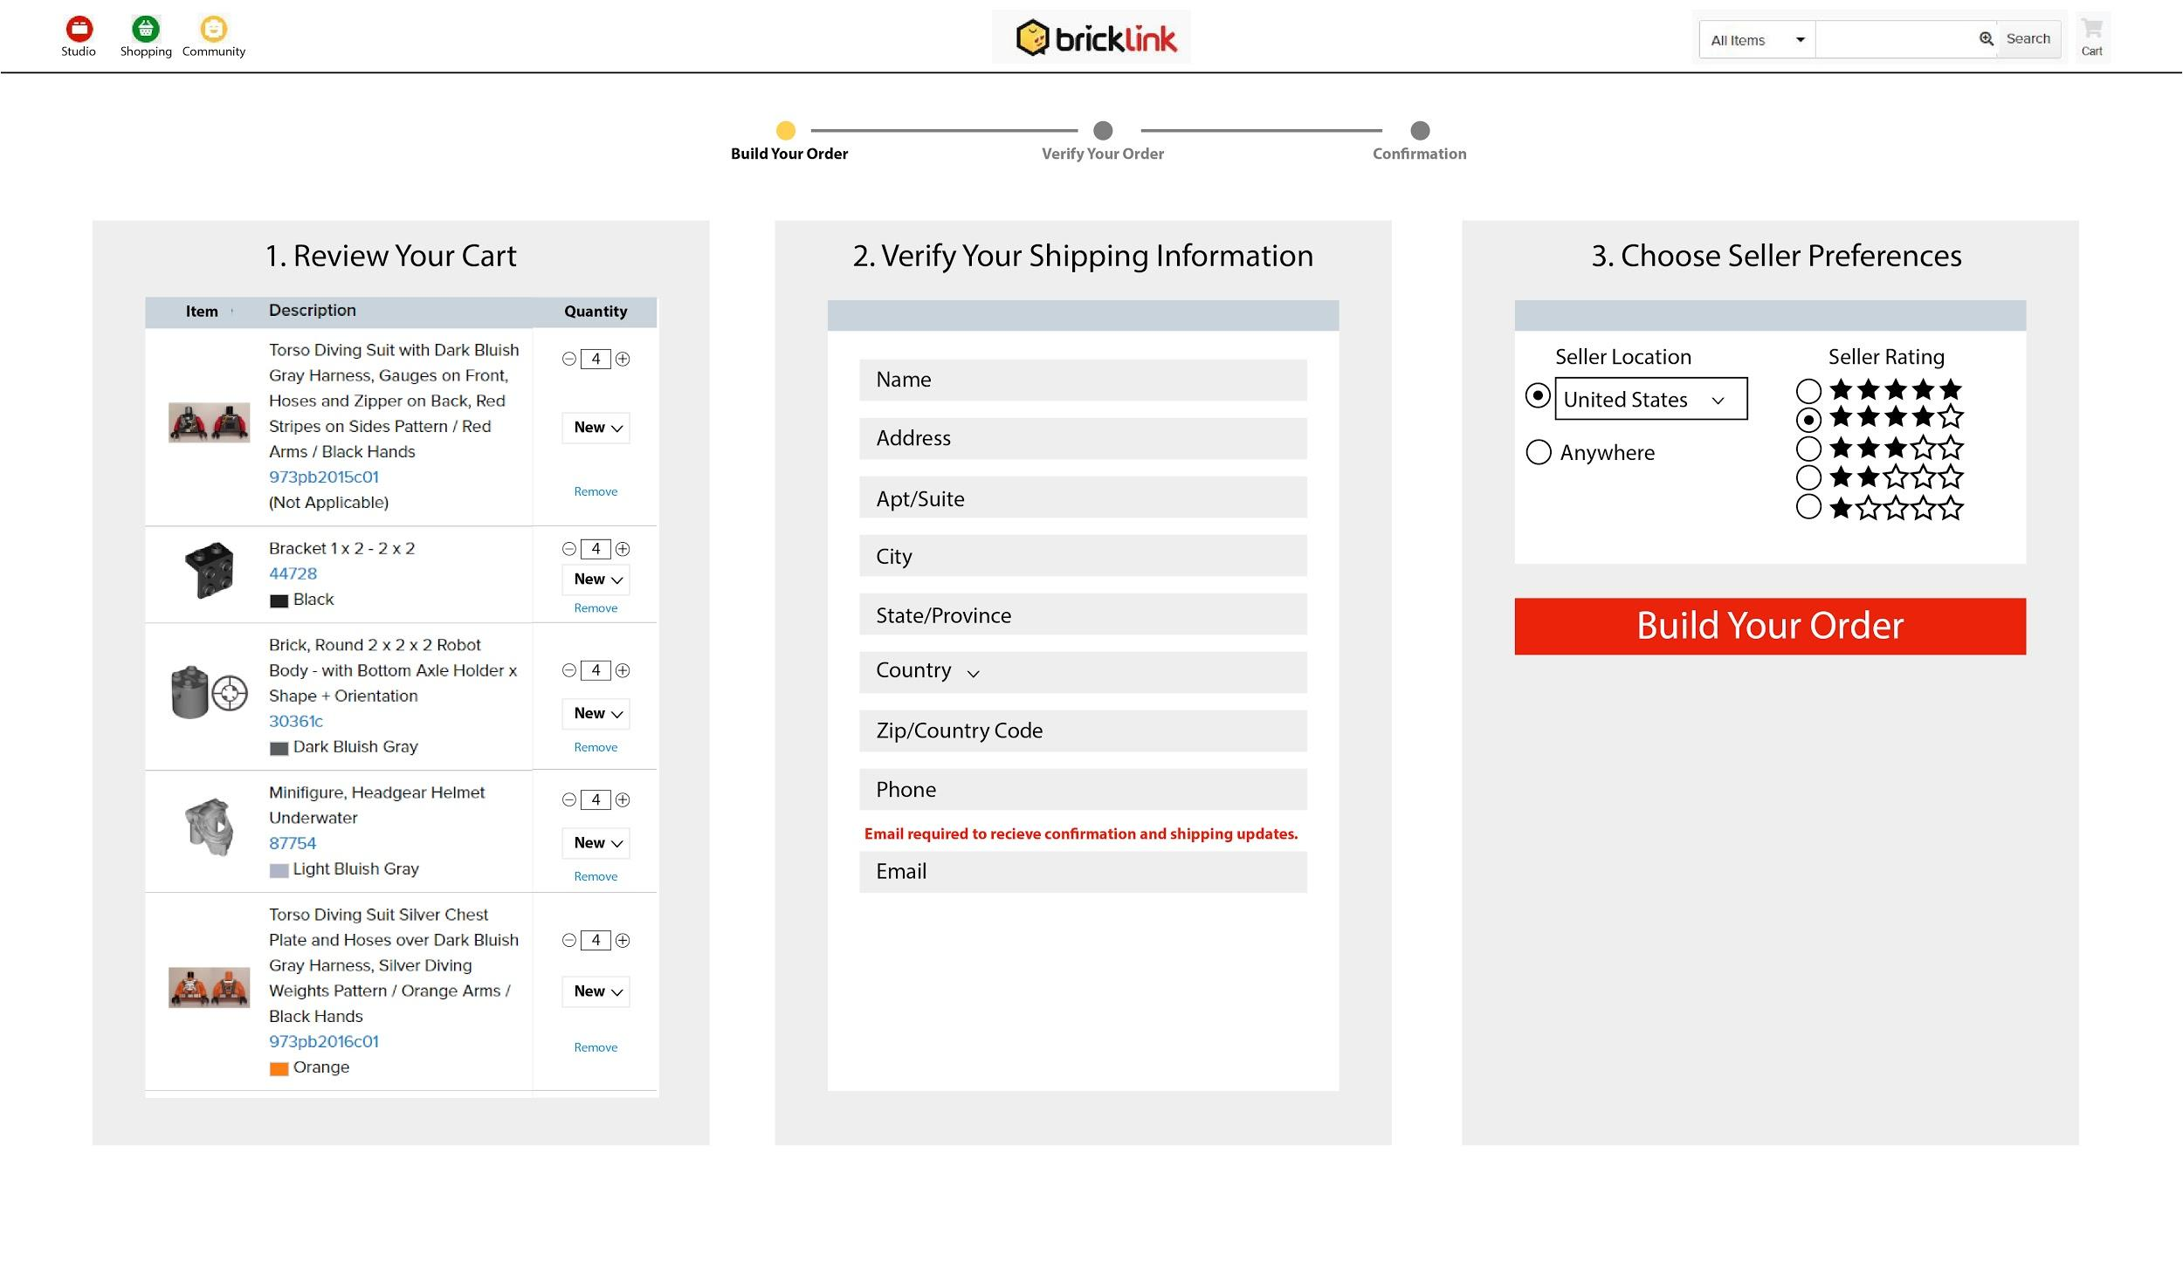

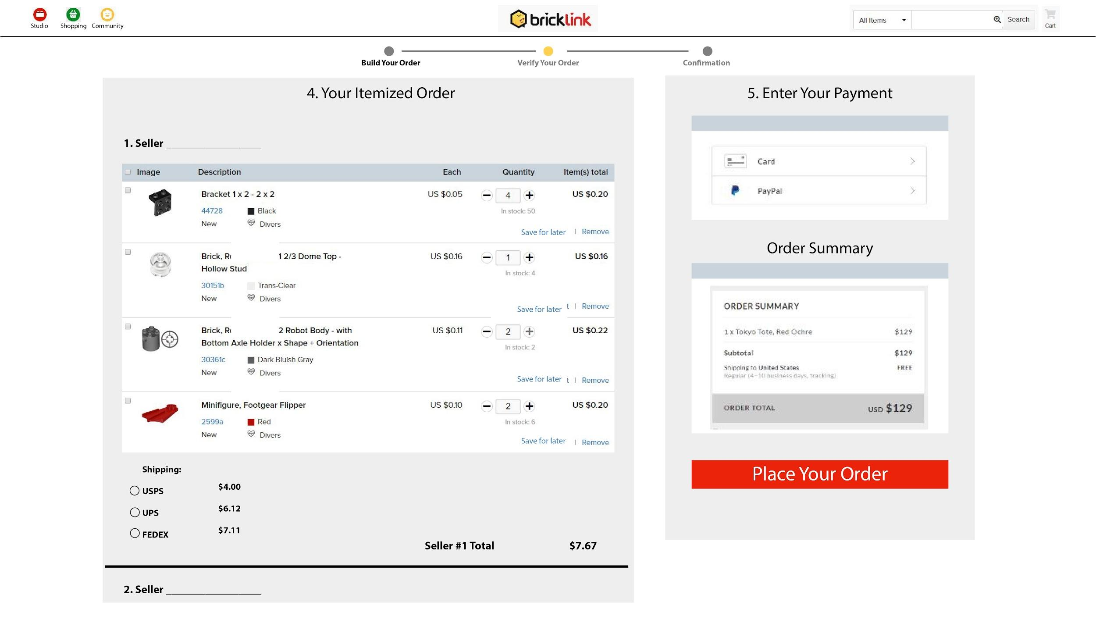

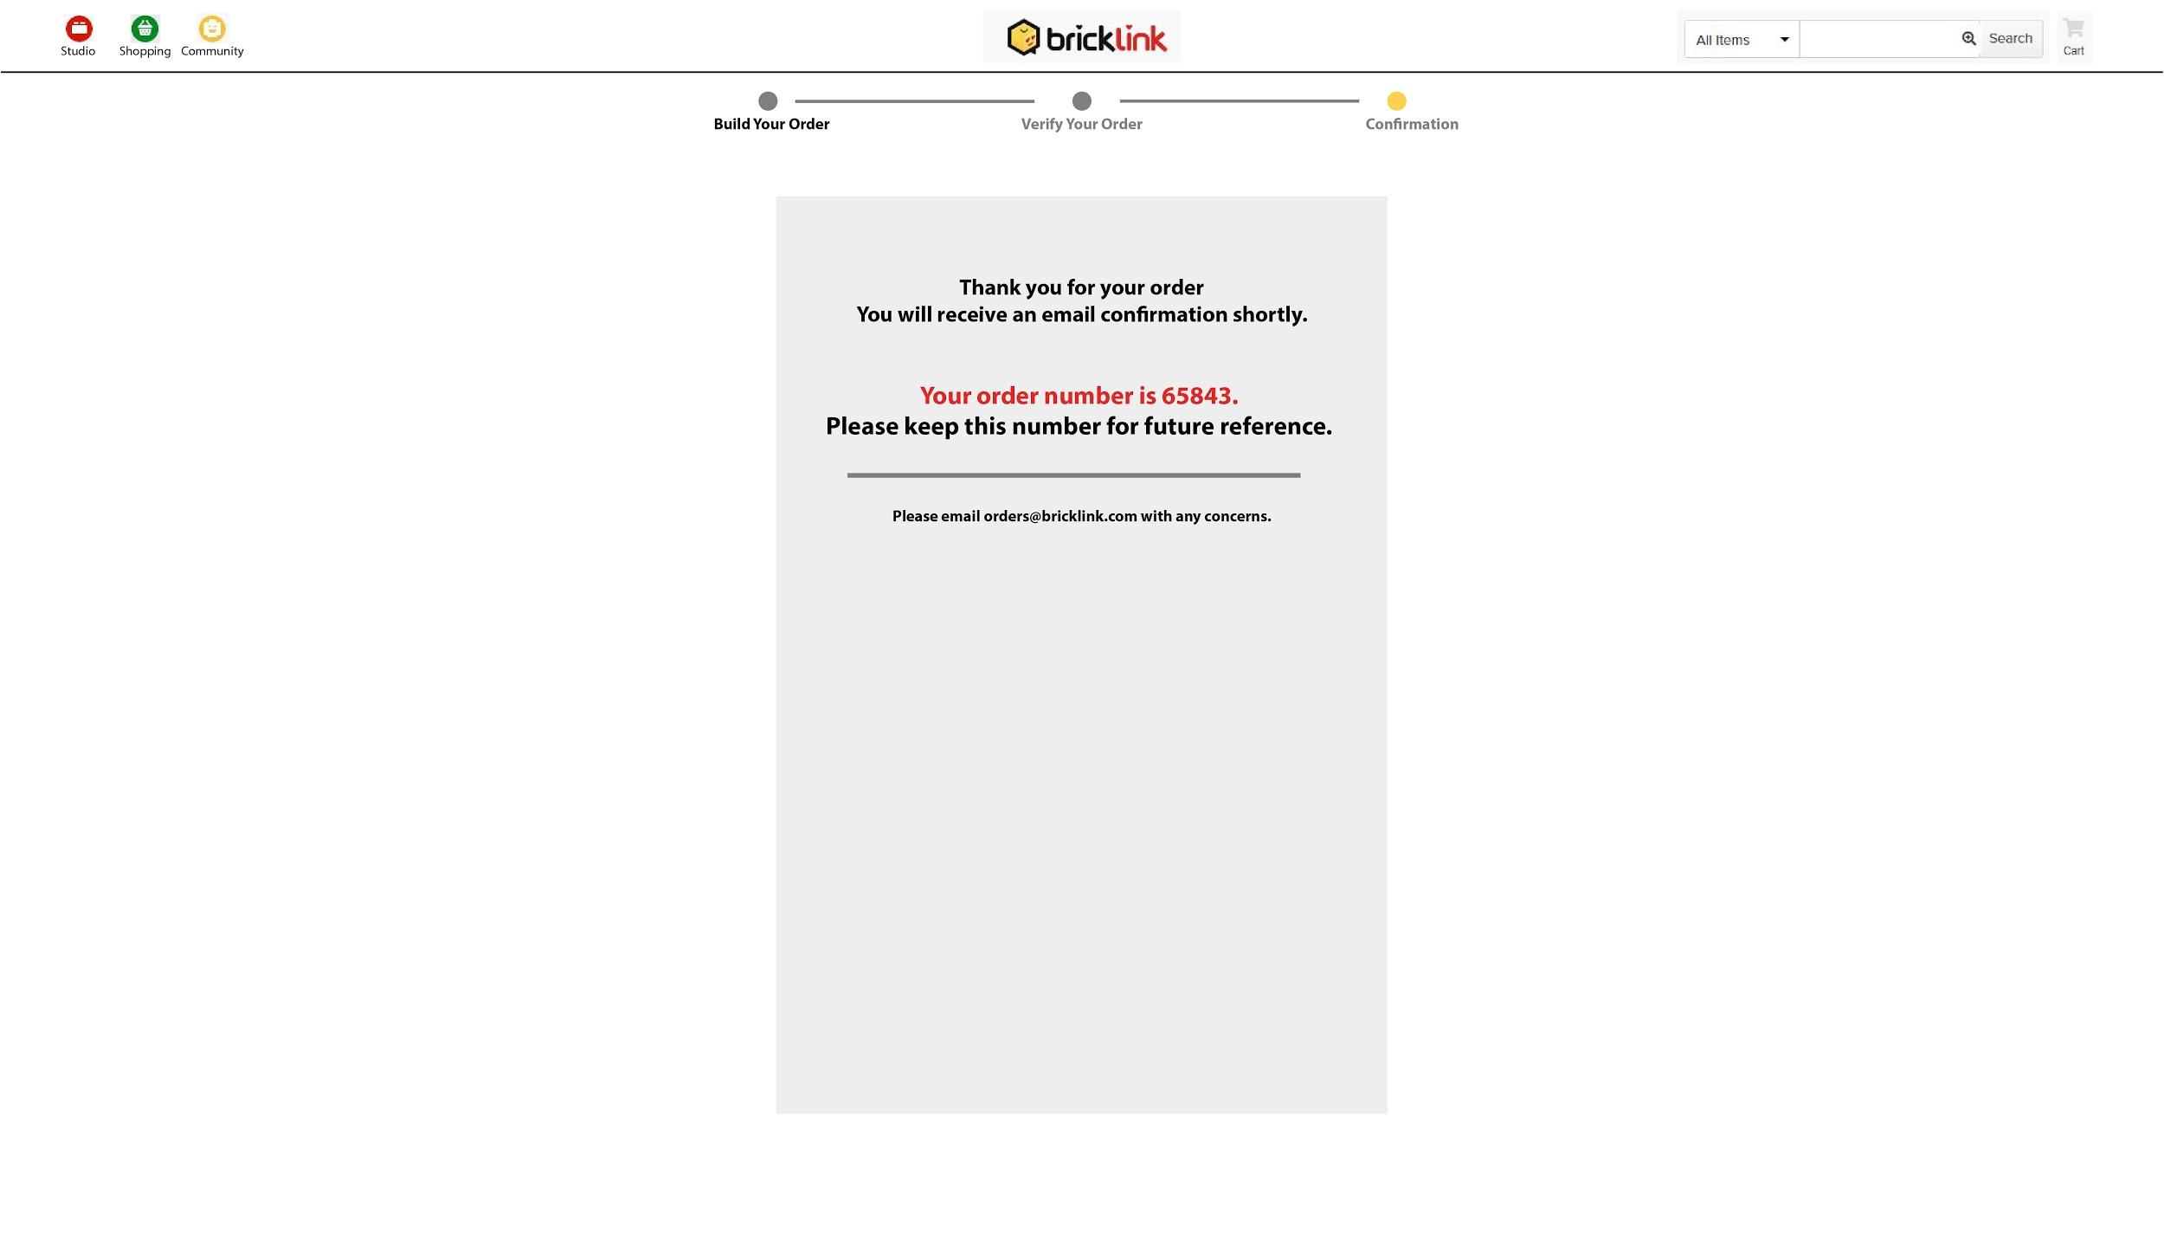

## **Prototype**

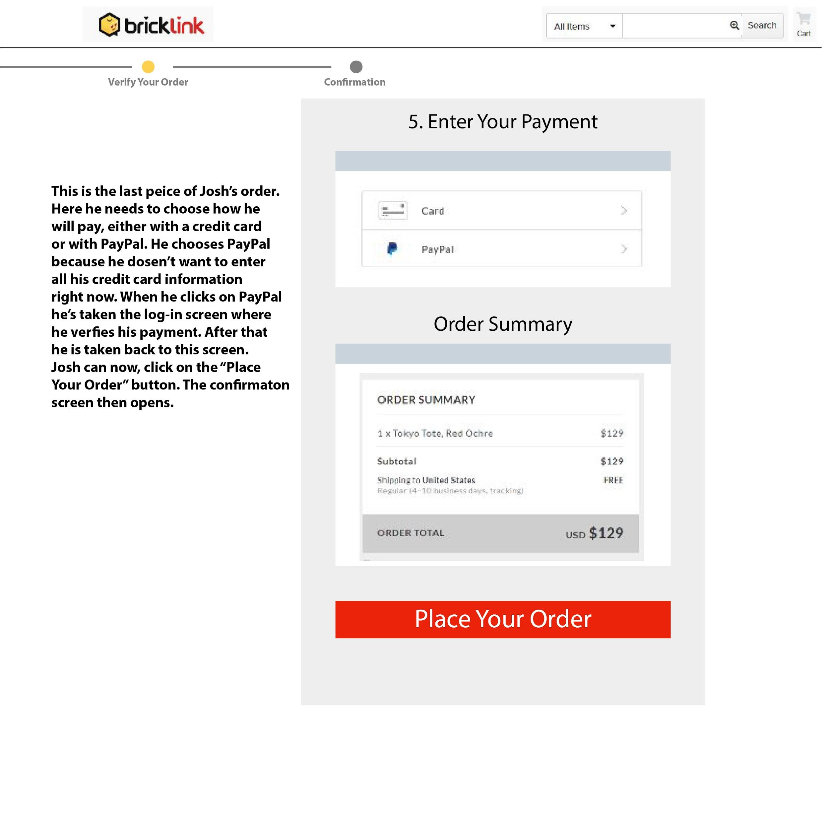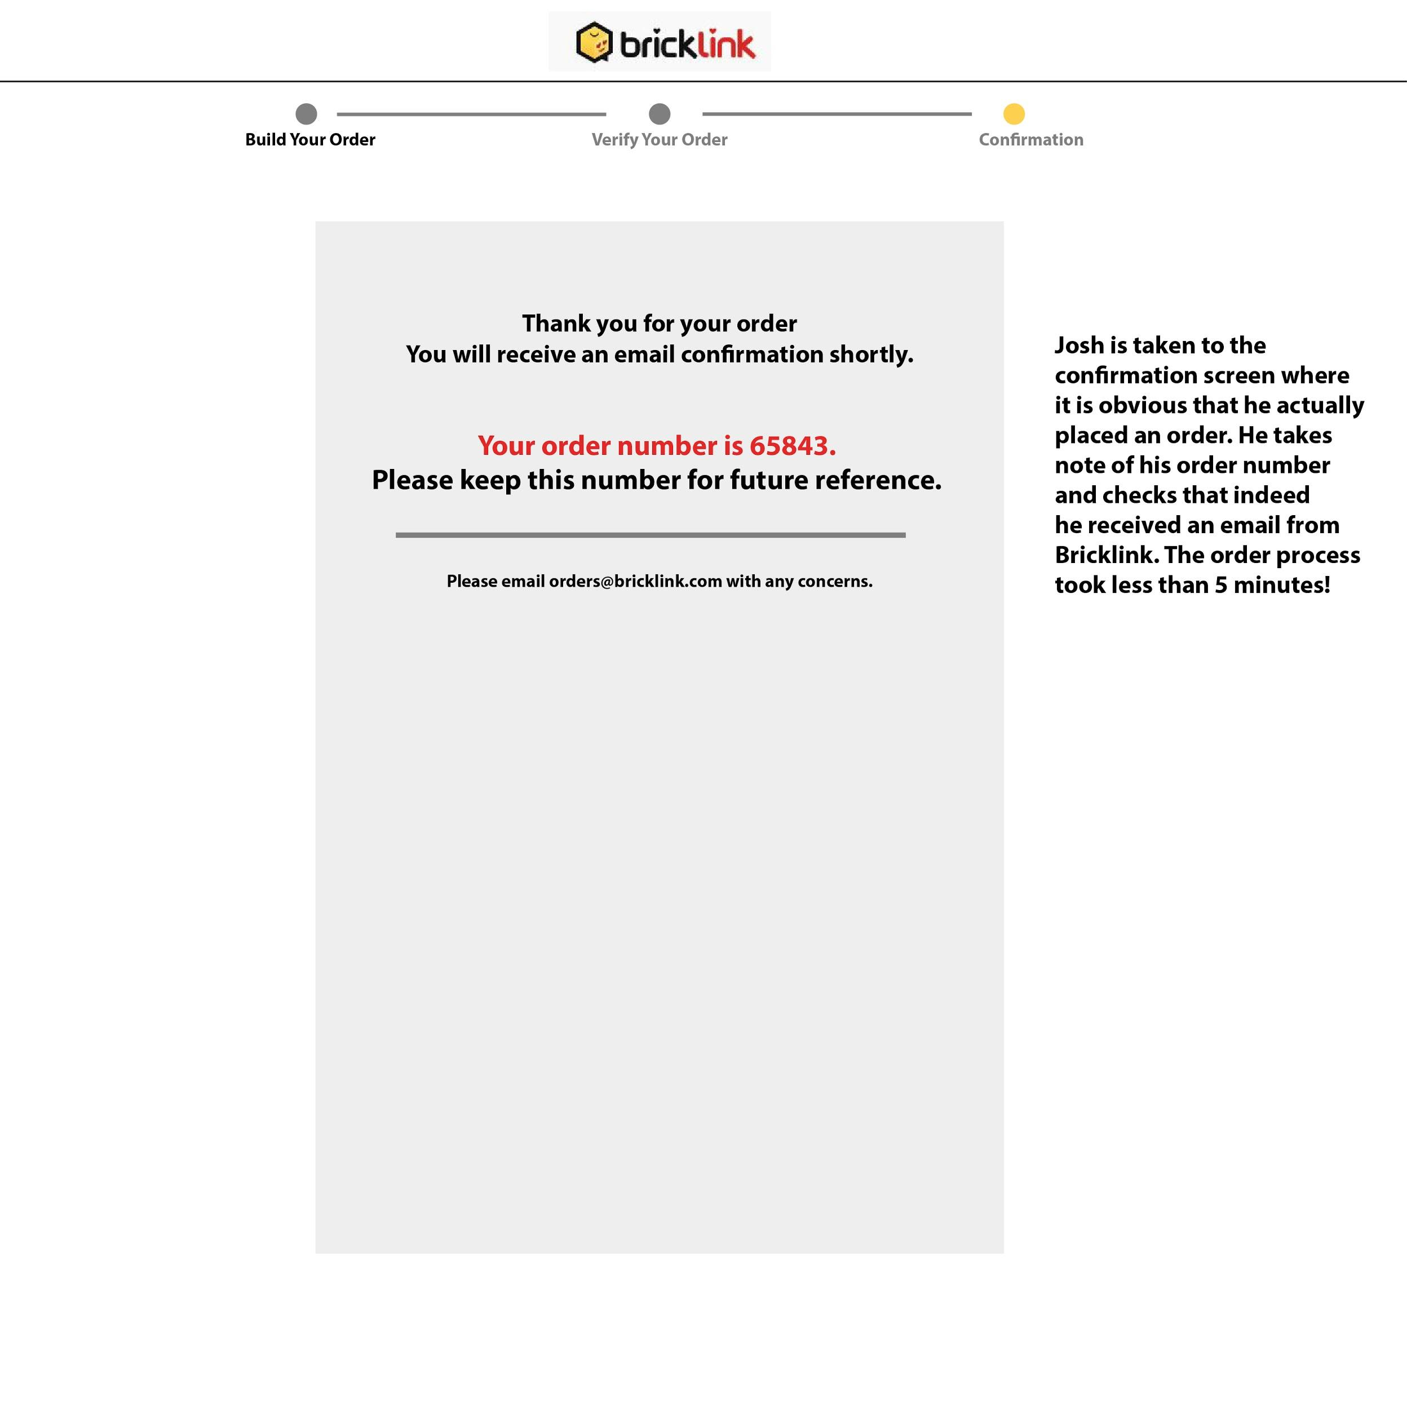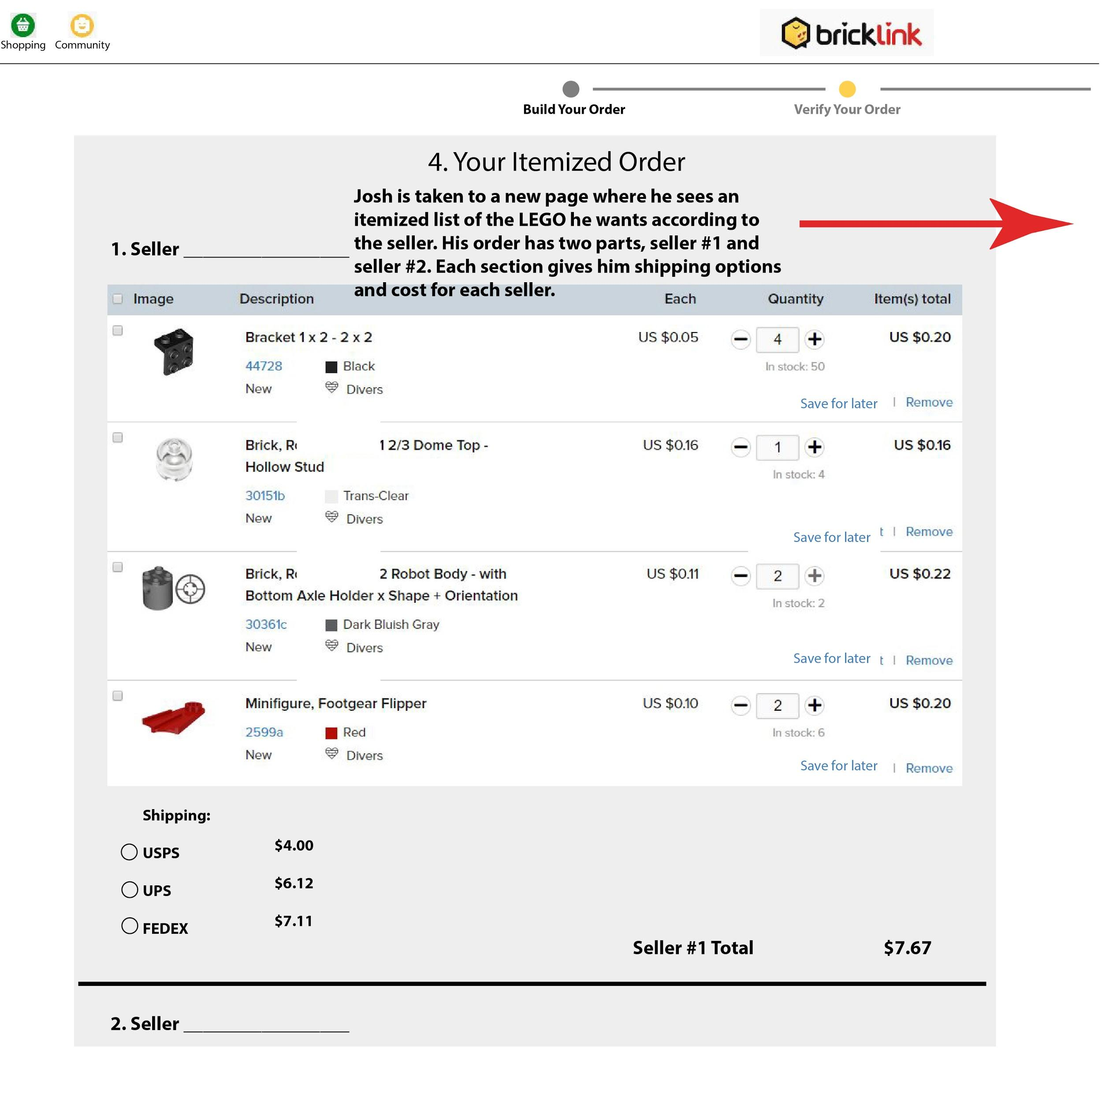

## **Specification**

### Executive Summary

Anybody can order from bricklink.com. The design of the new bricklink.com website shopping cart will bring together all the features of the ordering process into one cohesive unit. From start to finish, the path a customer takes from finding a seller to making a payment will be clear.

### Criteria

|  |  |  |
| --- | --- | --- |
| **Name** | **Criteria** | **Priority** |
| **Speed** | The order process should not take too long for anyone. | Priority 1: Speed is an important consideration. If it takes too long then the customer may not place an order and that would be considered a failure. |
| **Complete** | The order process should include all the necessary information. | Priority 1: If the customer is unsure about the order or its pricing and shipping then they will probably not place an order and this would be a failure. |
| **Regular** | The order process should be familiar with other checkout processes. | Priority 2: It would certainly be useful for the order process to be like other checkouts the customer has encountered. It is not a prerequisite for success. A user could still figure out an unfamiliar layout. |
| **Authentic** | The order process must appear to be reputable. | Priority 1:If there is any part of the ordering process that does not give the correct feedback or look authentic then this would cause failure. |
| **Look** | The page should be fun to look at, like LEGO. | Priority 3: It would be nice if everything was fun and exciting but this would not affect if the user actually bought something. It isn’t something I will go out of my way to achieve. |

### Persona

Josh is a 40-year old professional and father. He loves to build with LEGO and share them with his children as a hobby. He is busy but interested in spending time being creative with his family.

### Scenario

Josh comes home from work to spend time with his family. He and his 12-year-old son want to build a Batman LEGO set. Josh goes to Bricklink.com to find the required parts and places an order. He goes through selecting the parts, confirming his order, his contact information and payment.

### Screen-Shots





### Detailed Design

**Review Cart**

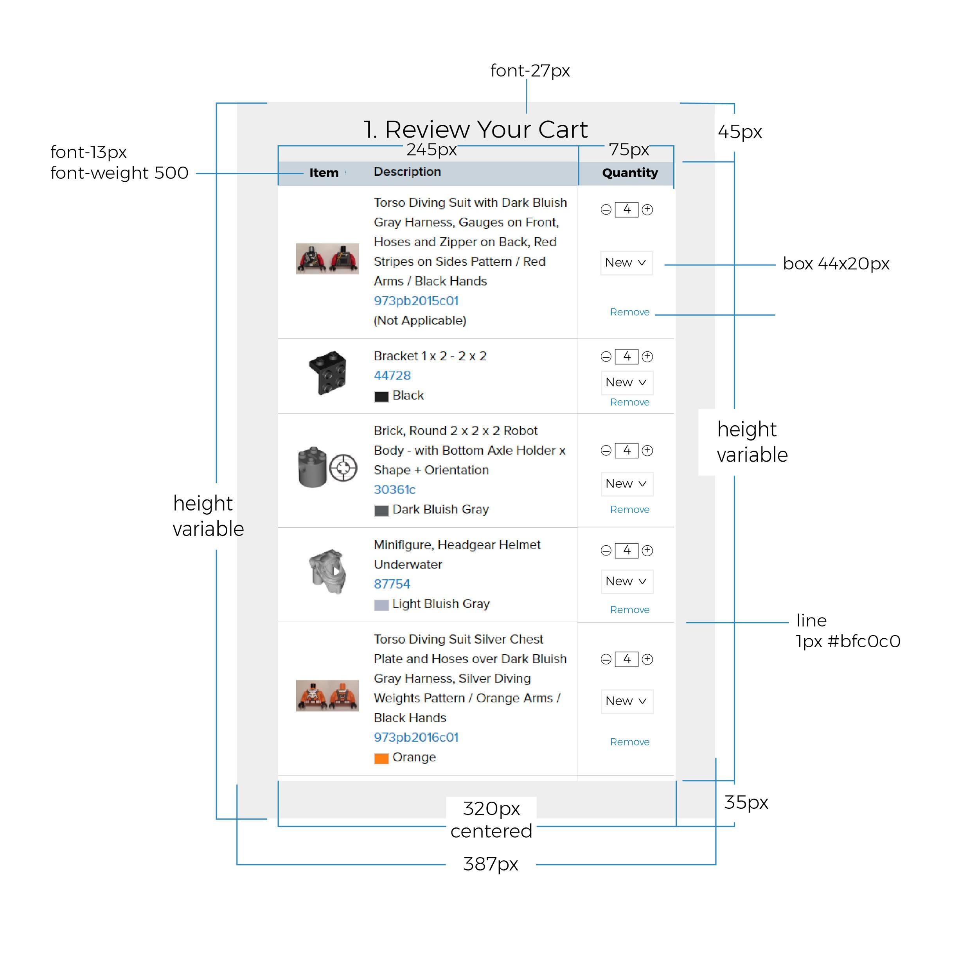

**Customer Information**

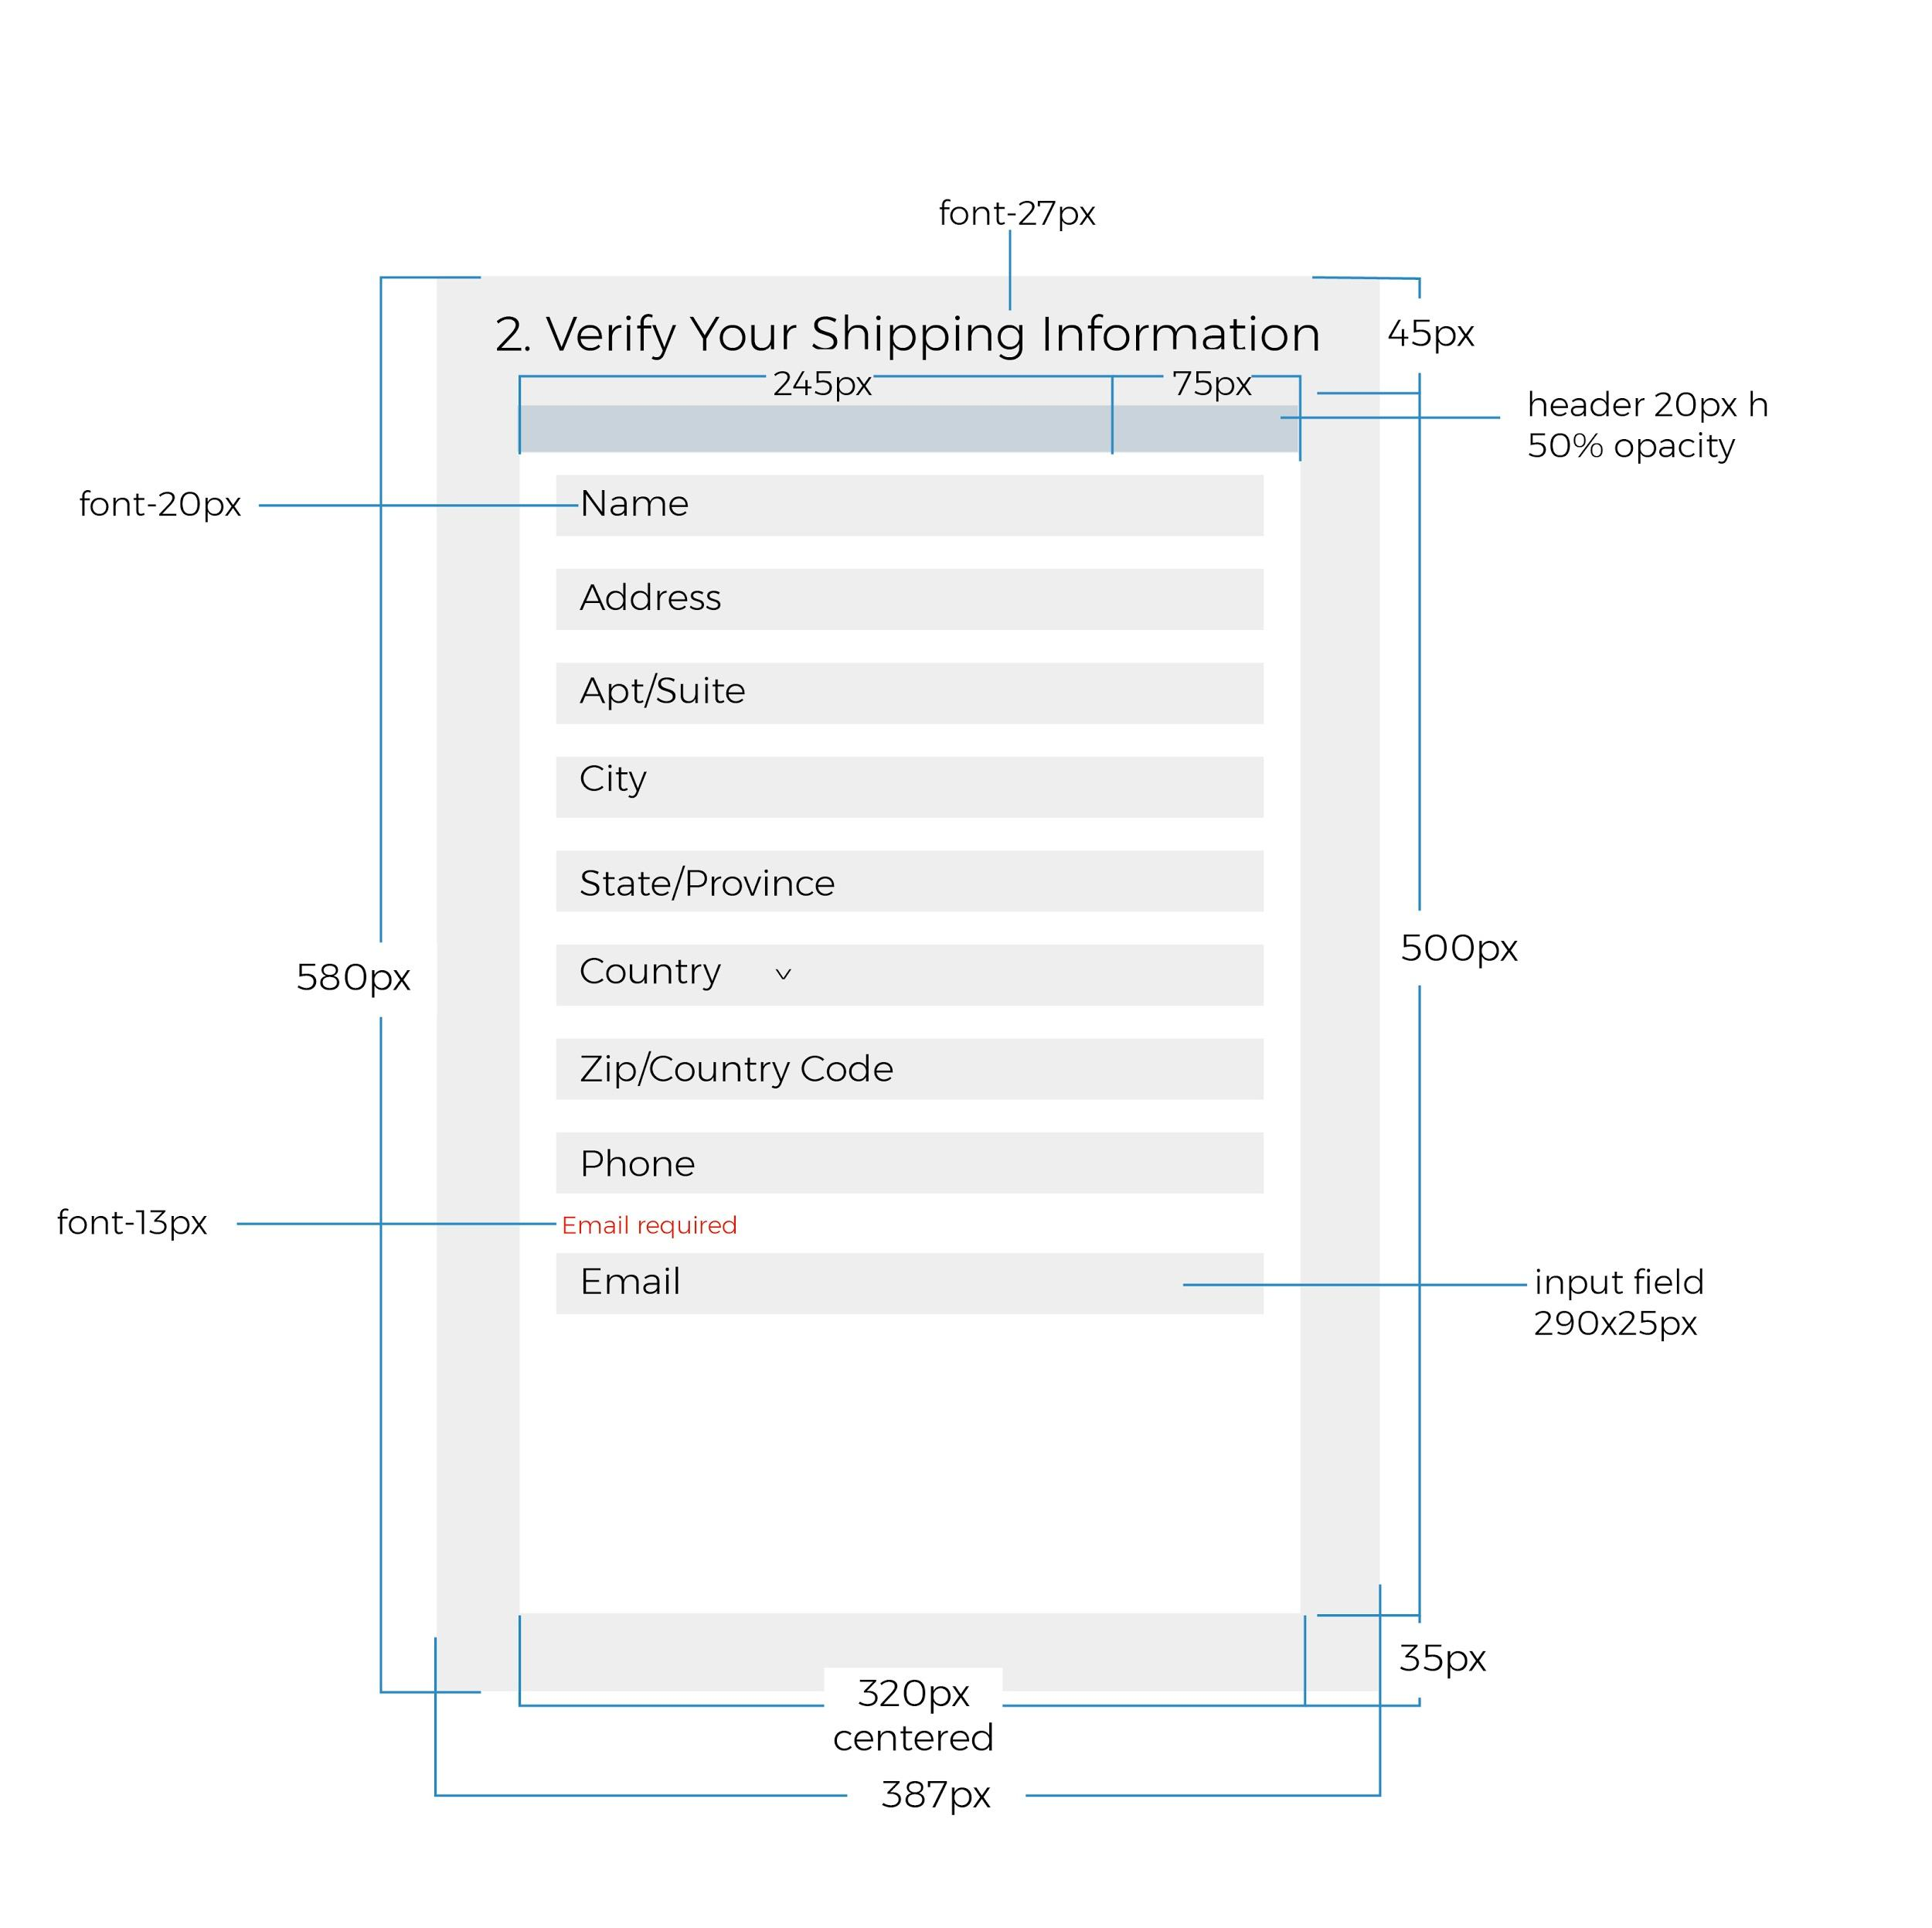

**Seller Preferences**

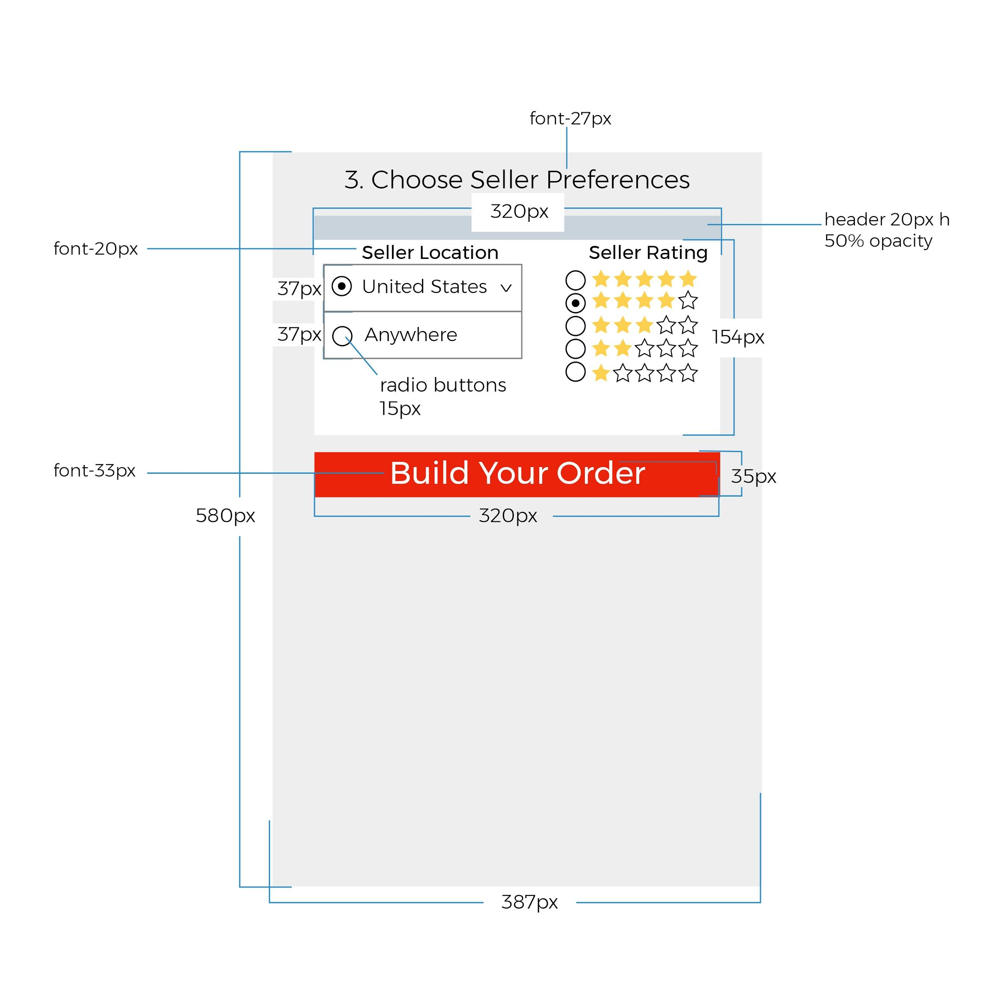

**Itemized Order**

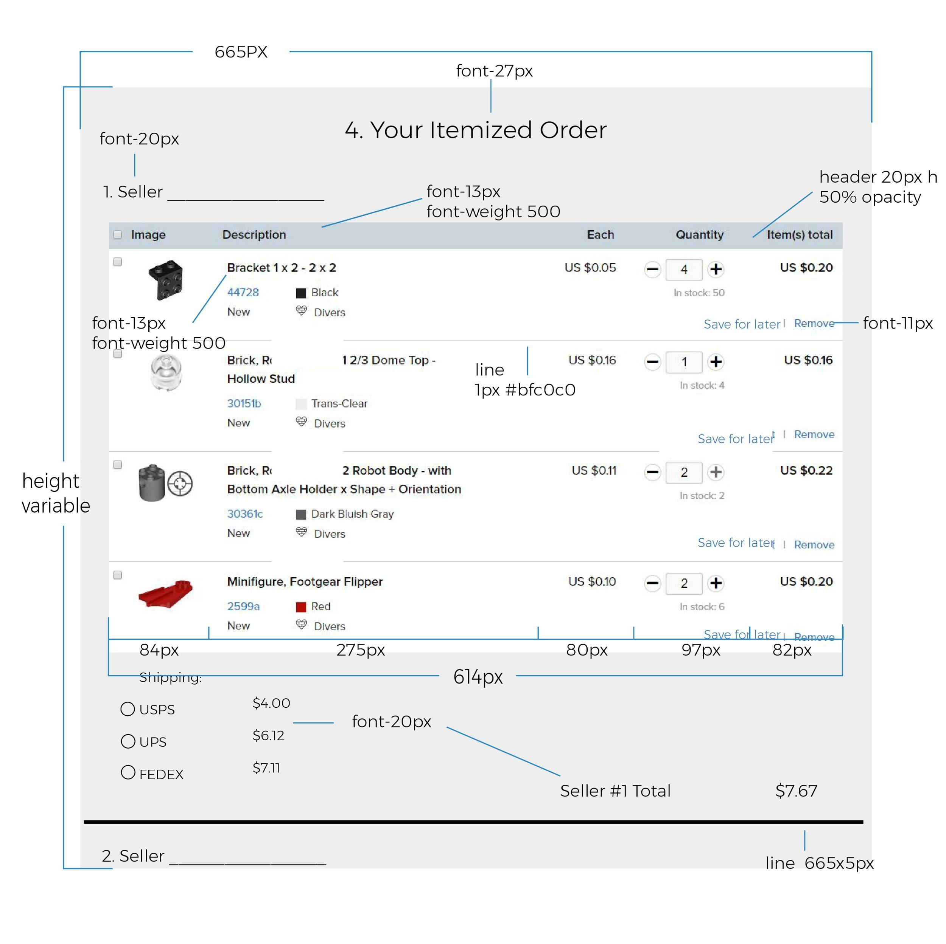

**Payment Information**

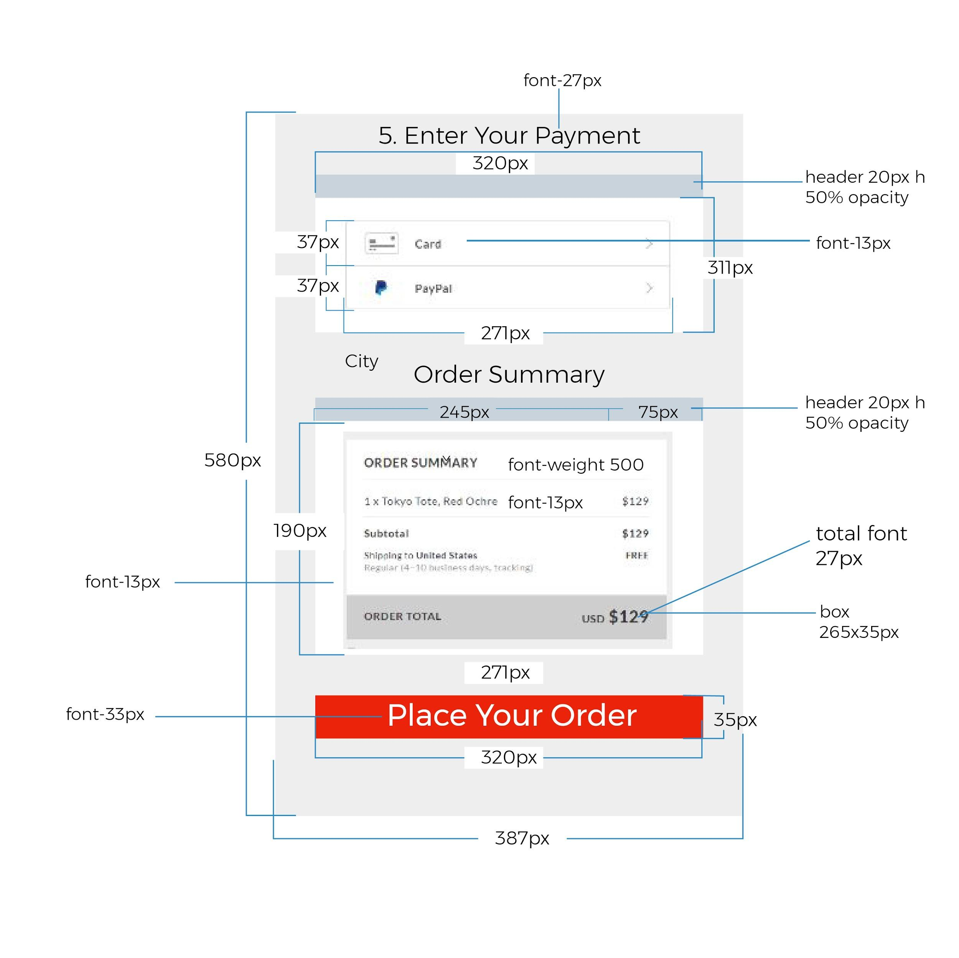

**Confirmation Screen**

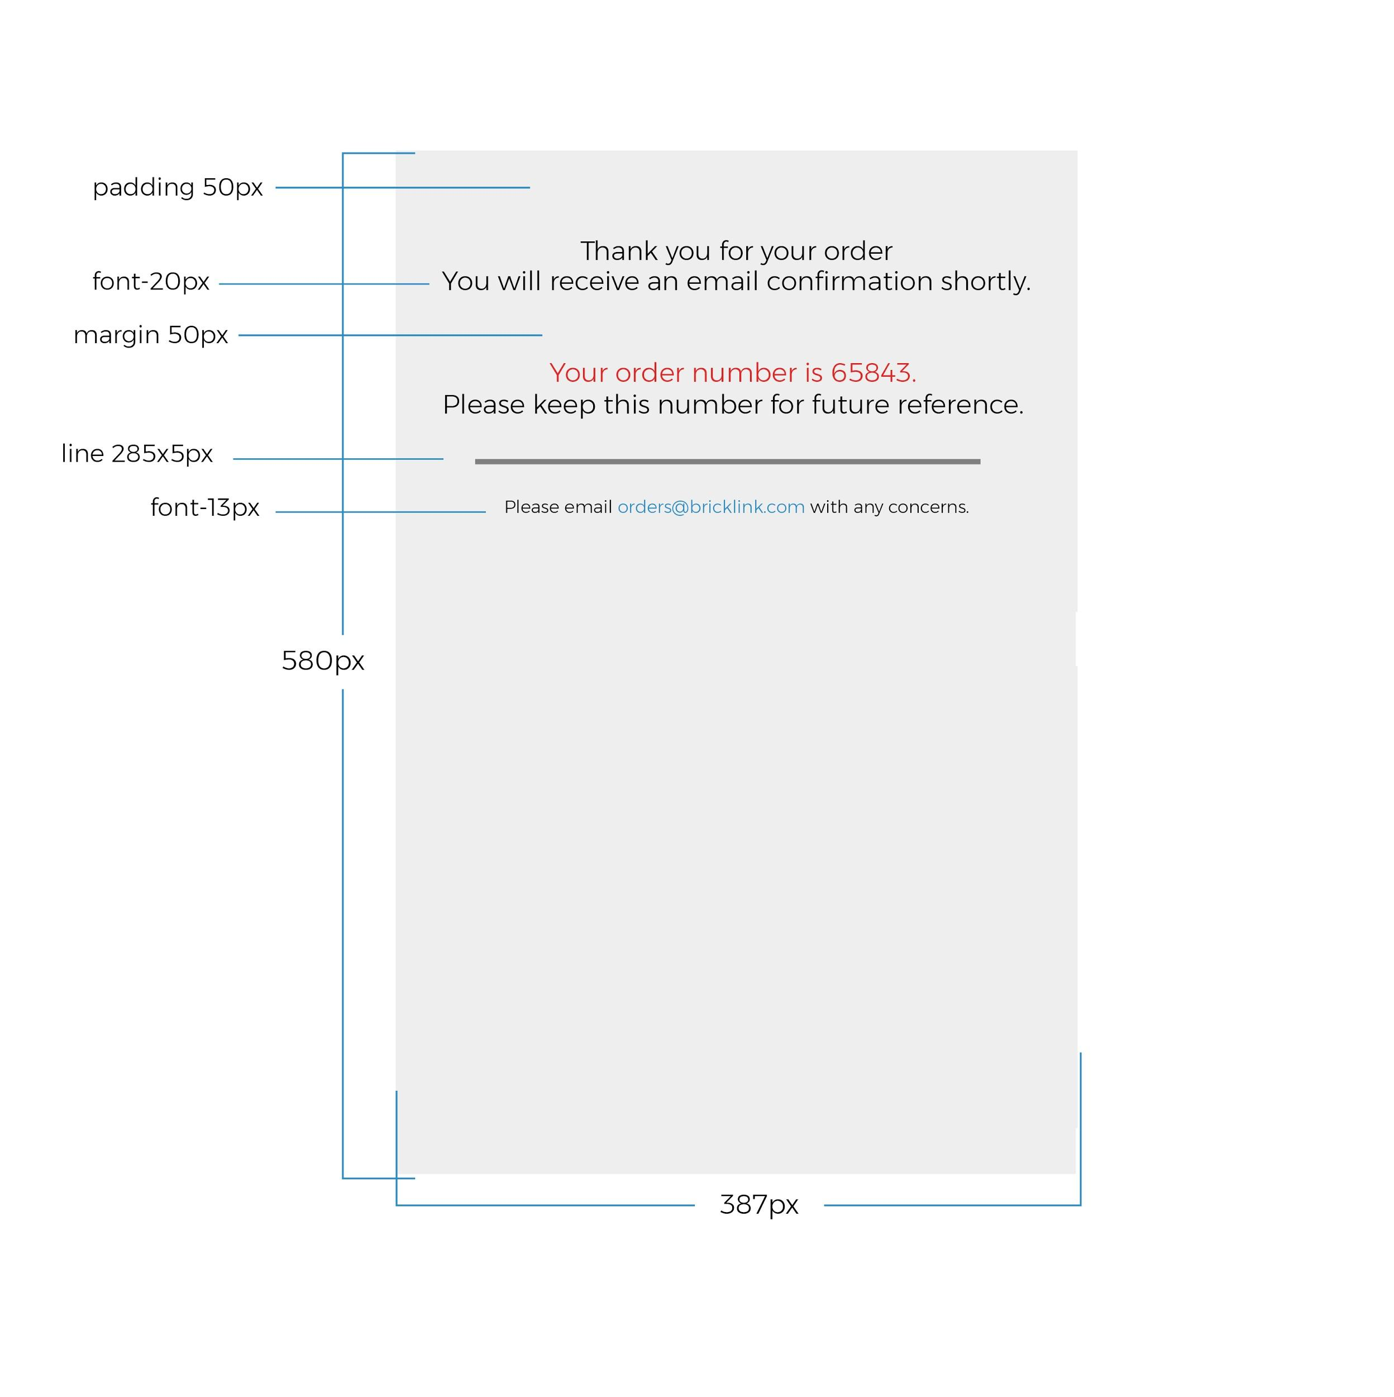

**Link States Button States Color Palette**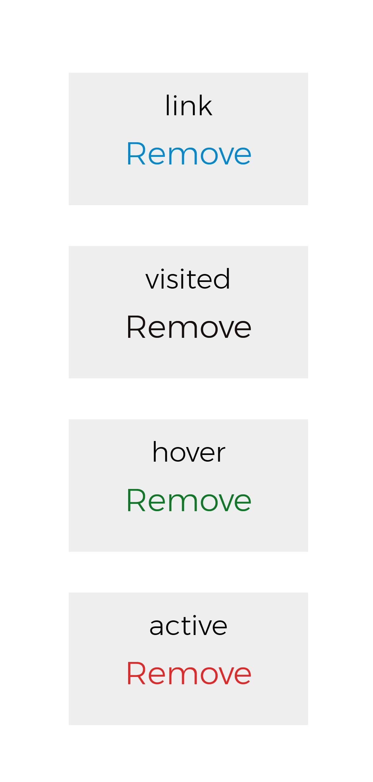

**Status Bar**